Our manifesto, ‘Homo Sapiens to Homo Digitalis’ is to examine group 8’s concerns bought about by the introduction of the digital into our lives.
Technological advancement needs to be examined from a moral and spiritual perspective, as well as from a legislative and educational angle.
I would like to try and find solutions through making pictures that effectively address our concerns and suggest solutions, my appropriation of the Yin Yang symbol was clumsy. I would like to balance out and juxtapose my work to show balance. I need to see how many other spiritual base ethos fit my enquiry so it may correctly be seen as an inspirational thought, not a statement and go on looking for "my way.”

In 500 words, I shall be able to address one point of this manifesto. The feelings of loneliness bought about by isolation occur with both cyber violations and with addiction. Artists do and have made inquiries into this in the past.
Michael Ignatieff In his book The Needs of Strangers uses Shakespeare’s King Lear, Saint Augustine’s Confessions, Hieronymus Bosch’s paintings to illustrate the problems while finding possible solutions through Hume, Rousseau, and Adam Smith.
Scientists exploring addiction, eating disorders, depression and antisocial behaviour, are suggesting that treating the feelings of loneliness may well be a route to recovery and re-inclusion into society.
Johann Hari discusses this in his ted talk, everything you think you know about addiction is wrong (Johann Hari | TEDGlobalLondon)
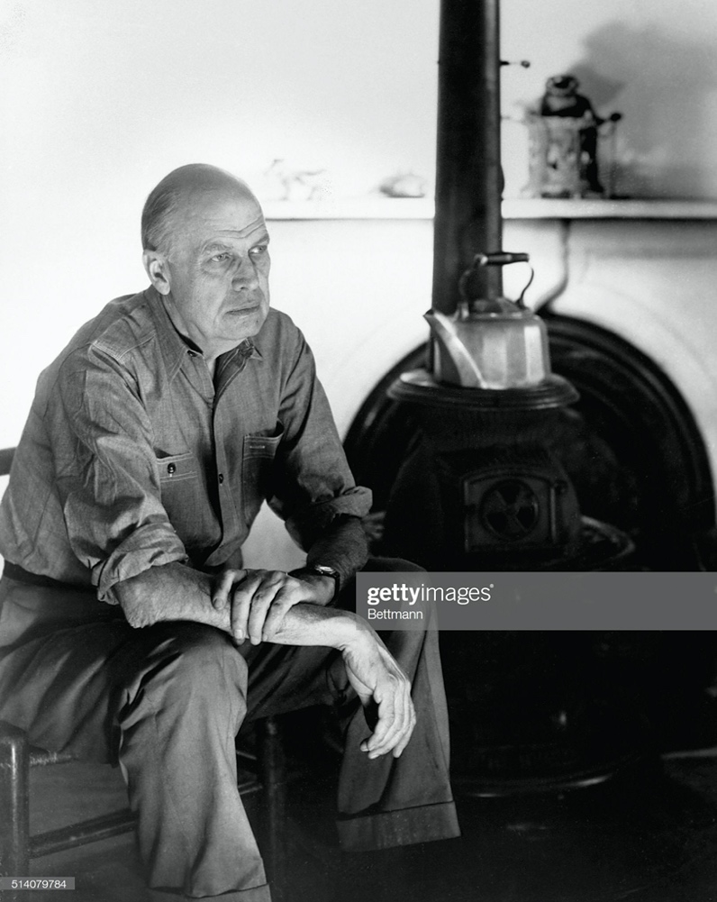
Artist Edward Hopper described as a lonely teenager, explored solitude in his paintings. and by doing so connected with others and they in turn connected with him.
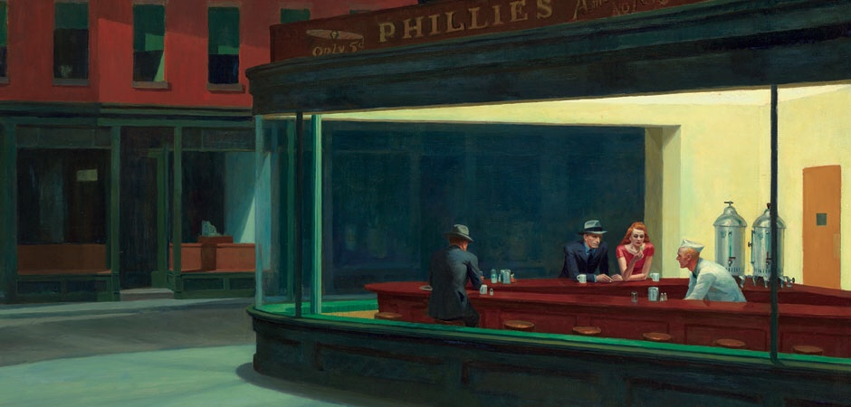
Nighthawks, 1942 oil on canvas painting by Edward Hopper.
Jeff Koons's “transponder” paintings, give us a reflection of ourselves and include us in the narrative of the work we are looking at. “That’s where the art is. The object doesn’t have any art in it; it’s just a transponder that can stimulate. The art happens inside the viewer”.
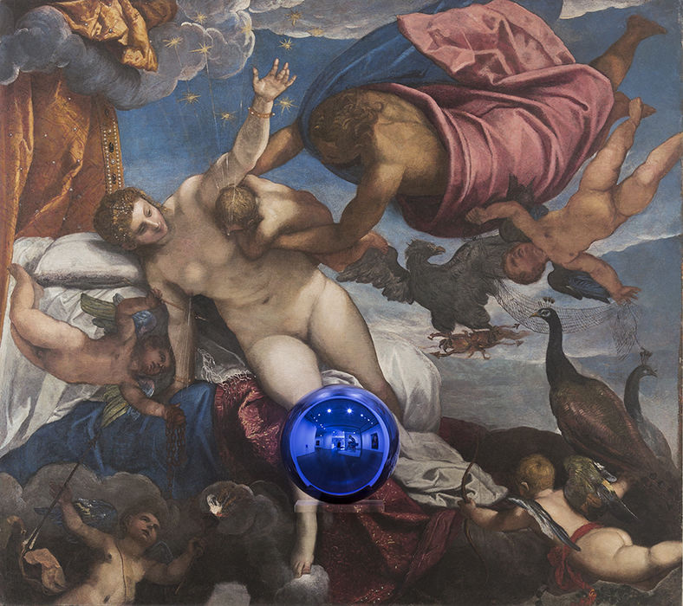

Jeff Koons gazing-ball-tintoretto-the-origin-of-the-milky-way.

Maybe these pieces make the audience and the artist, in turn, feel less isolated.
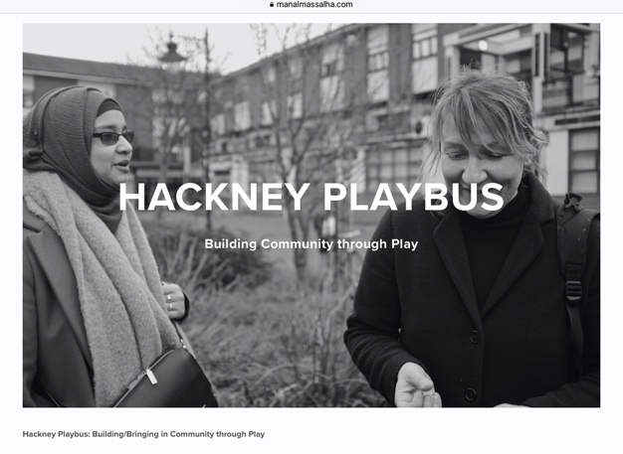
Manal Massalha an ethnographer and photographer engages “with the everyday and the mundane, the human and the urban, the cultural and the social, the political and the economical.” She must make her subjects feel less alone and has given them exposure on platforms where they may be heard.
Computers have gone from the size of a small house to something you hold in your hand they are all around us and in some cases, in us. They are not going away, so we need to address them.
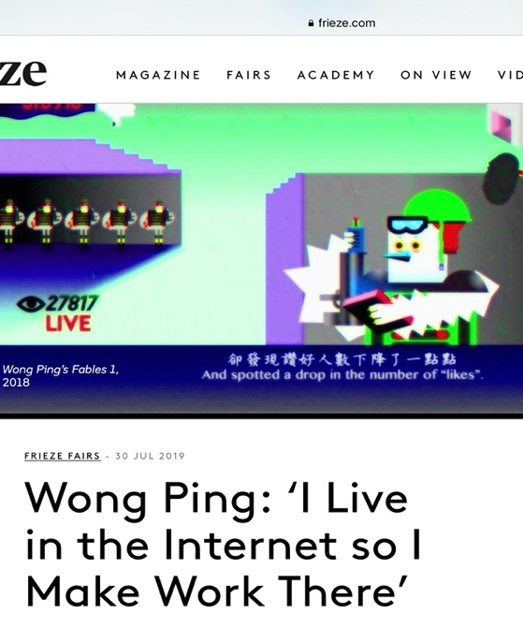
Wong Ping uses animation to retell stories and fables for a modern world. His artwork and life are very contemporary and every part of it touches technology. He works at the TV station; he likes reading and he takes time to show his animation to his parents which he says he enjoys. He seems to be successfully balancing his life. The simple approach is practical.
People should enjoy and engage with curiosity in the things they do. Looking at and appreciating what is around them, even if it is just what makes a lemon so lemon. I believe painting is able to give us conversation pieces, common ground on which to connect. By being attractive they can draw us in and” the art can happen inside us.”
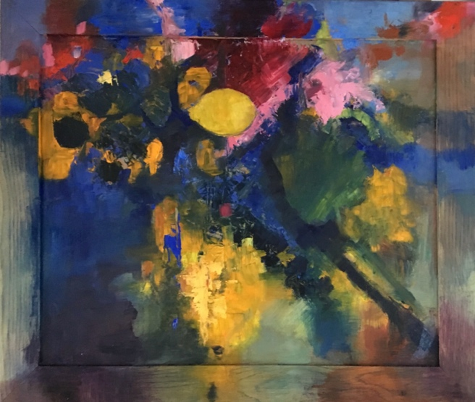, 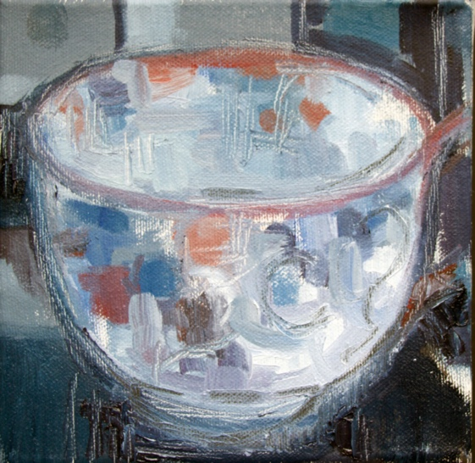
Cosmic Lemi 2019 chalkie Teacup 2019 Chalkie

Michael Ignatieff, The Needs of Strangers (Picador Usa, 1984).
Johann Hari, Everything You Think You Know about Addiction Is Wrong <https://www.ted.com/talks/johann_hari_everything_you_think_you_know_about_addiction_is_wrong> [accessed 27 October 2019].
Tess Thackara, ‘Understanding Edward Hopper’s Lonely Vision of America, beyond “Nighthawks”’, Artsy, 2018 <https://www.artsy.net/article/artsy-editorial-understanding-edward-hoppers-lonely-vision-america-nighthawks> [accessed 27 October 2019].
‘Jeff Koons on His Five Most Ambitious Unrealized Projects - Artsy’ <https://www.artsy.net/article/artsy-editorial-jeff-koons-five-ambitious-unrealized-projects> [accessed 27 October 2019].
‘Manal Massalha | LensCulture’ <https://www.lensculture.com/manal-massalha> [accessed 27 October 2019].
‘Wong Ping: “I Live in the Internet so I Make Work There” | Frieze’ <https://frieze.com/media/wong-ping-heart-digger> [accessed 27 October 2019].

