Sarah Chalkie Cloonan

Individual 500 Word Critical Reflection - RCA Grad. Dip FA Pathway 2019/20.

By writing this critical reflection I have realised and have identified many changes in my practise. There lies the crux of what I would like to say. Writing has become central to my critical reflective process.

In reflecting and writing critically about my research and outcomes I have begun to understand my work within historical, contemporary philosophies and practices. Preparing for the future I have asked, what am I doing, who is it for, why and how? Objective drawing and painting, have given way to photography in conjunction with drawing as a research method, coupled with informed reading and listening to historical information and other people’s current opinions. An objective painting is now not my predetermined outcome, my practice has expanded. I have updated myself on what is currently considered art and the many ways, methods and productive processes involved. Observation is important to me, I believe in looking and recording objectively, but research has allowed me to introduce other forms of seeing and examining that I feel are equally important, deconstruction is one example.

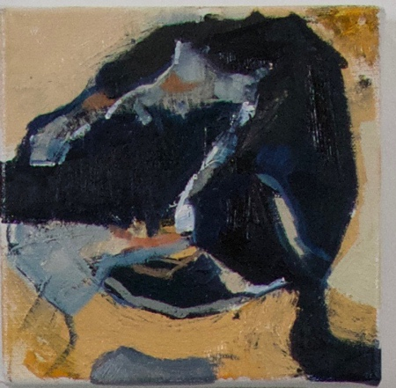

Deconstructed Ballet Shoe 2019
20 cmx 20 cm 0il on canvas, Sarah Chalkie Cloonan
My ideas have been allowed to surface and now drive my output. I have slowed down and connected to my ideas, allowing some quiet spaces to expand my thoughts and reflect, critically horning down to a deeper level to examine the subject at hand. Critical writing, planning, blogging with research is central to this process, I have a new perspective, a new modus operandi. My research into Mark Bradford and “Social Abstraction” helped me resolve my internal struggle and I realised that what I have painted before is linked to what I am doing now. I found I was unable to engage with my ideas as my interests had grown away from my original intentions as a painter. I now include my personal, social concerns and have reconnected. This was the reason I was finding it difficult to describe what I was doing . By looking at the bigger picture, as advised, researching, becoming critically engaged with my subject and then evaluating, I see a path and have gained the ability to edit and streamline where necessary to achieve a completed project. I was resistant to change at first, but with the support of my tutors, advice and collaboration with the other students, the material information, methodologies, ideas along with the subjects we were exposed too- in course lectures, workshops, shows and RCA talks - being encouraged to place research at the start of my projects I have taken a leap of faith. This change has allowed me to move forwards in a contemporary and critical way engaging with subject matter that I have not examined before. I hope to continue to build on both the teaching and mentoring while developing my own practise, I have made contact with myself and feel better equipped to look out using “Social Abstraction” I bring my past forward and plan my practice, now inclusive, for the future without conflict.

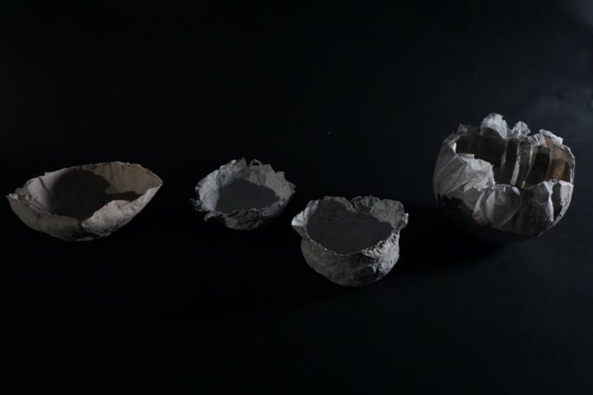
Cosmic bowls 2020
Made from Paper- high & low, Gesso and Domestic ingrediencies. Sarah Chalkie Cloonan.
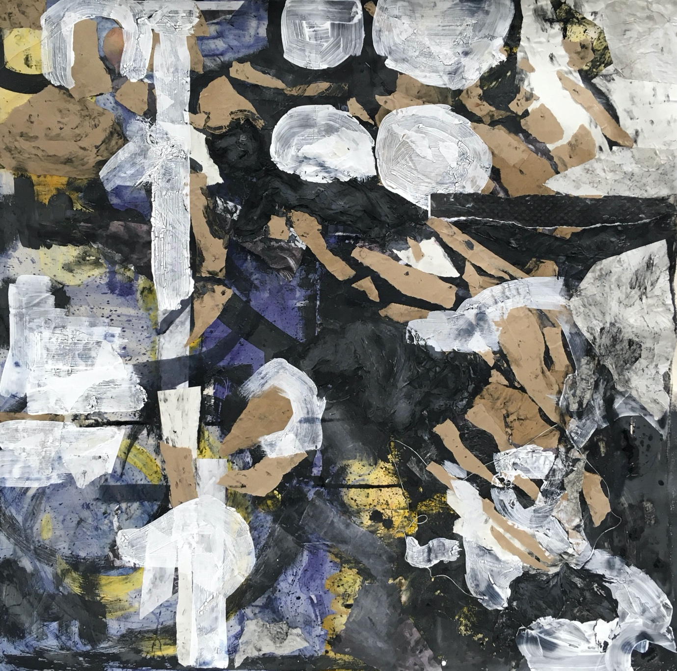
Love Letter, Clay and Brown Paper. 2020
Paper, Clay and Domestic Ingredients on Canvas. Sarah Chalkie Cloonan.

‘Deconstruction – Art Term | Tate’ <https://www.tate.org.uk/art/art-terms/d/deconstruction> [accessed 26 February 2020].
‘Sarah Chalkie Cloonan – Painting, Art, RCA Grad.Dip Chalkie@chalkie.Com’ <https://chalkiecloonanrcagraddip.wordpress.com/> [accessed 26 February 2020].
‘Snapshot’ <https://www.newyorker.com/magazine/2015/06/22/what-else-can-art-do?verso=true> [accessed 9 January 2020].
‘Rca Talks - Google Search’ <https://www.google.com/search?q=rca+talks&oq=rca+talks&aqs=chrome..69i57j33.5639j1j4&sourceid=chrome&ie=UTF-8> [accessed 26 February 2020].
‘Mark Bradford: The Artist and Ex-Hairdresser Forcing America to Face Ugly Truths about Itself | Art and Design | The Guardian’ <https://www.theguardian.com/artanddesign/2017/nov/14/mark-bradford-artist-interview-picketts-charge-civil-war> [accessed 26 February 2020].

